3.1.2 Celsius to Fahrenheit
Algorithm
Step 1:- Start
Step 2:- Read the temperature in Celsius → C
Step 3:- Apply the formula:
$$F=(C×\frac{9}{5})+32$$
Step 4:- Display the temperature in Fahrenheit → F
Step 5:- End

FLOWCHART
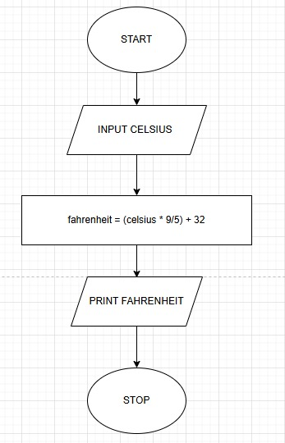

PYTHON CODE
celsius = float(input())
fahrenheit = (celsius *1.8)+32
print(f"{fahrenheit:.2f}")

EXECUTION